Supplies: socks, scissors, tempera paint, puffy paint, plastic bags, paint brushes
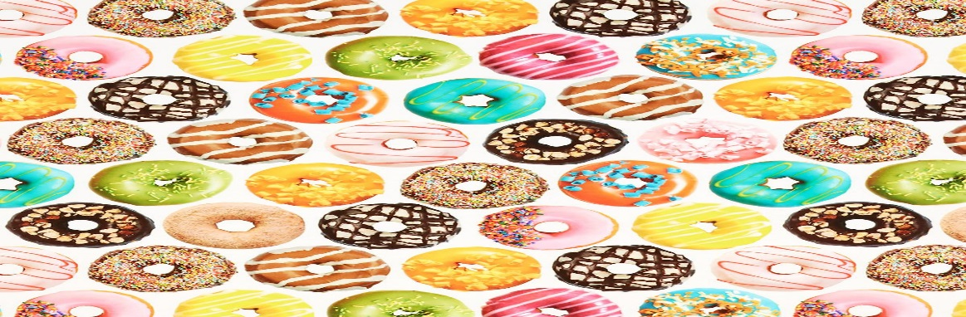

I watched this video to understand the process and I teach it very direct instruction when the students complete a part I have them put it in the air. https://video.search.yahoo.com/search/video;_ylt=A0LEV1XFx9pZihoA2AJXNyoA;_ylu=X3oDMTB0N2Noc21lBGNvbG8DYmYxBHBvcwMxBHZ0aWQDBHNlYwNwaXZz?p=sock+donuts&fr2=piv-web
I also have the kids watch the video how it is made
https://www.youtube.com/watch?v=i0h2rZWZhBg
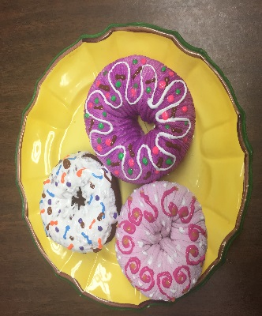
Standards
CREATING
Generate and conceptualize artistic ideas and work — elaborate on imaginative ideas—apply knowledge to develop personal ideas in artwork
Organize and develop artistic ideas and work — create personal artwork—demonstrate understanding proficient use of materials—construct everyday life representations
Presenting/producing
Analyze, interpret and select artistic work for presentation— Investigate and discuss possibilities and limitations of spaces for exhibiting artwork
Responding
Apply criteria to evaluate artistic work— evaluate an artwork based on a given criterion
Connecting
Synthesize and relate knowledge and personal experiences to make art- develop a work of art based on observations of surroundings
Evaluation:
Can the student tell me at least 2 facts about donut/making process?
Did the student fill the donuts with bright colors and patterns?

